Aryan Sai Venkat M

230701040 CSE A

EXP NO:5 System Calls Programming

PROGRAM

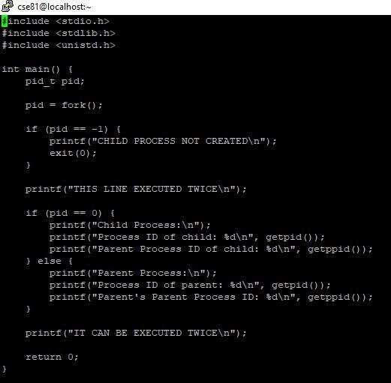

OUTPUT

1

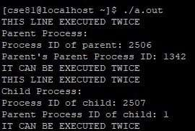

2